BANKING SYSTEM INTEGRATION REPORT
ONE MINKY MOSETSE
CSE24-036
The banking system has been integrated connecting all major components into a fully functioning banking application. The system uses JAVAFX for the user interface and text files for storage

INTEGRATED MODULES
USER INTERFACE
-Login screen for both customers and bank tellers
- customer and bank teller dashboard
- transaction screen
-account history viewings

APPLICATION LOGIC
-Handles user interactions and button clicks
-Manages navigation between different screens
- Processes banking transactions

BANKING OPERATIONS
-Deposit and withdrawal processing
- interest calculations
- Tracks balance

DATA STORAGE
-Texte files for customer information
-Text files for account data
-Transaction history logging

Integration Testing
This test shows that a customer can login and execute fund transfers such as deposit and withdrawals resulting in the system updating what has been executed . it also shows the ability for a bank teller to login and execute their responsibilities such as adding a new customer.

The first thing a user sees is the login screen in which they will select their respective positions
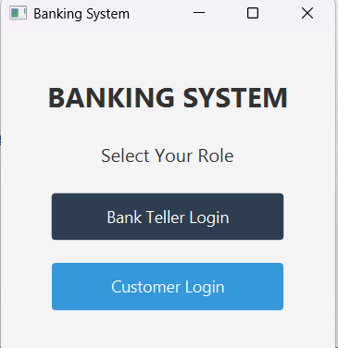 This shows the login screen

If the bank teller logins in they press the bank teller login showing a screen where they can enter their credentials which then leads to the bank teller dashboard.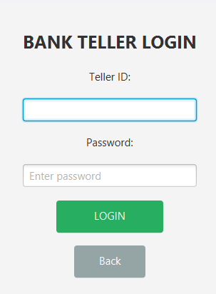 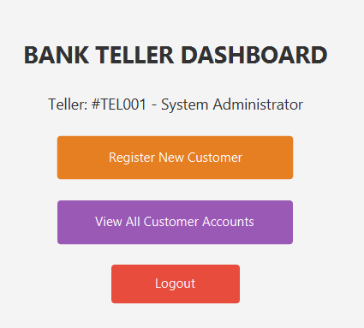

The bank teller can view all customers accounts and also add a new customer
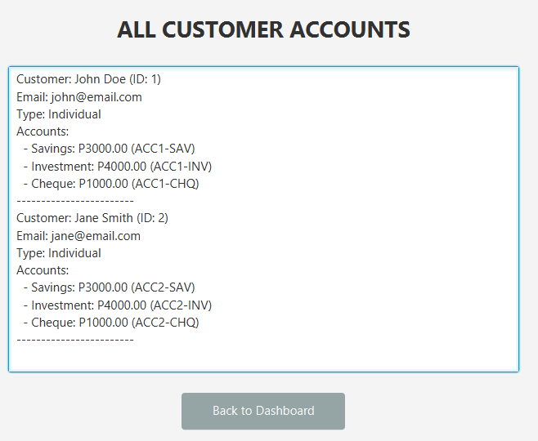

After executing their task the bank teller can log out of the banking system which will thale them back to the login screen.

CUSTOMER
The customer has a login screen in which they get to enter their data and login in the banking system to see their account and execute their transactions

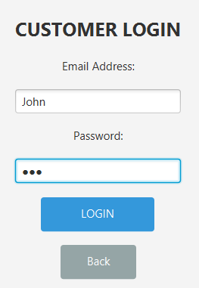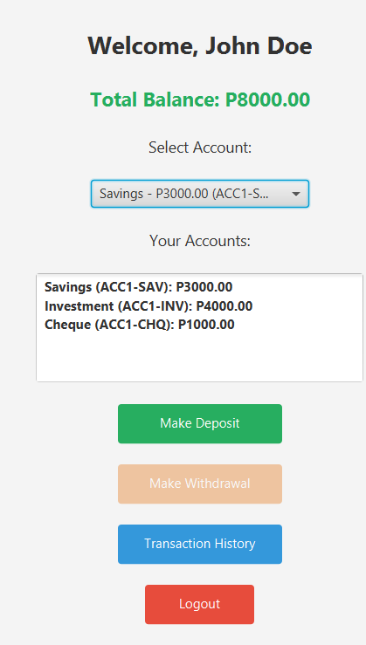

The customer can then make a deposit, withdrawal , and view transaction history this all depending on which account theyre using which can either be a cheque, savings or investment account. This all shown in the customer dashboard .

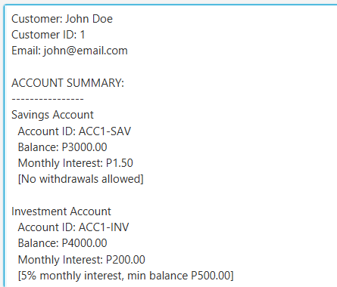 this is the transaction history of the customer

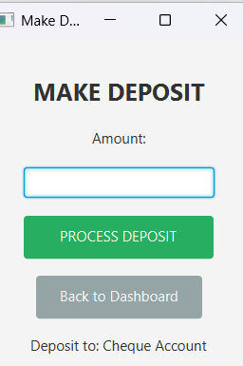 the customer can make a deposit

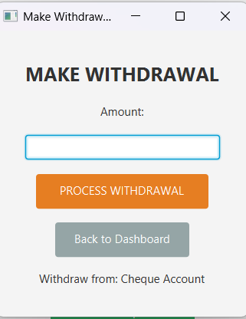 the customer makes a withdrawal

SUMMARY
The banking system is fully integrated and operational. All modules work together to provide a full baking system, The system handles user authentication , account management , transaction processing and data storage without any problems making it ready to use

